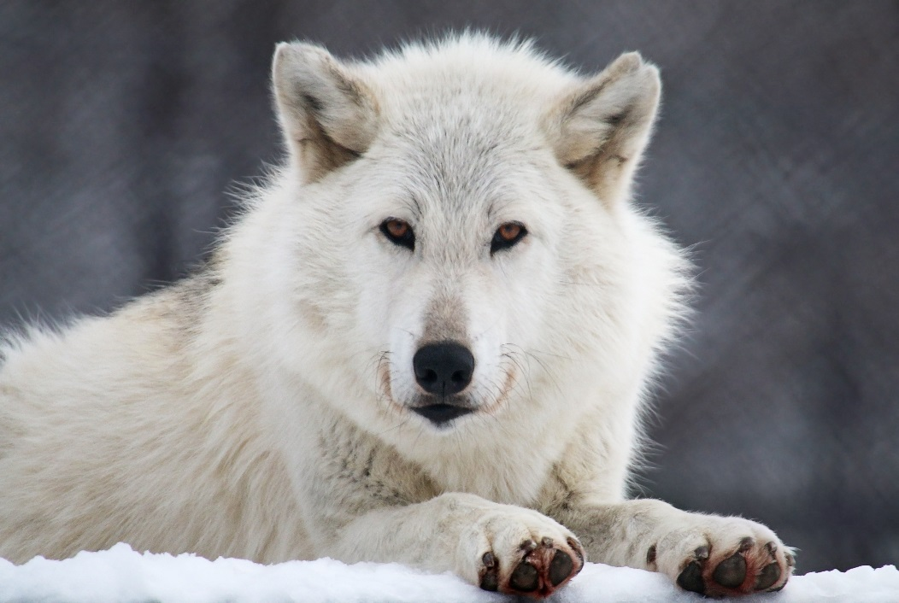

Tala

Head Animal Caretaker’s Message…Will Pryor

Reflections from the Mountain...

A leaf from Grandmother Maple falls slowly to the earth. Its face painted autumn red, twisting and turning, lingering forever on the scented breeze.

How many leaves have fallen...unnoticed, disappearing into the earth? How many warriors and wolves have fallen...unnoticed?

Sometimes I feel that my spirit takes an endless flight upon the autumn leaves.

Walking in the forest taking in the sights and smells of the moon of the falling leaves, being careful not to slip and go tumbling to the earth like so many of the tree leaves, my footsteps, quiet like a mouse, are my connection to life,

HOWL CHRONICLES

The Wolf Mountain Nature Center

562 Hopkins Crandall Rd., Smyrna, NY 13464
(607) 627-6784
twmncwolves@yahoo.com
TheWolfMountainNatureCenter.org

(a non-profit 501(c)3 organization)
Founded in 2006 by Will Pryor

to death, and to Mother Earth. I am grieving on this autumn day. There is a gaping hole in my soul that lets the air out and makes it hard to breathe. I reach out my hand to the most beautiful, gentle, strong friend, sister, teacher, I have had the honor of knowing...unconditional love. But she is no longer within my physical reach. Beginning at ten days of age I held her in my hands, cuddled her to keep her warm, fed her, slept by her side, and for the next 13+ years, became a social partner with Tala wolf. Countless days of visiting, resting under trees, and sharing the gift of life together sadly ended on October 27, 2021 as I was with my friend as she took her last breath. An incredible journey we had and will again one day run in the meadow and sleep under the trees together...of this I am certain.

November 2021

The howls of all the wolves have taken on a solemn sadness, a sense of loss they all feel and express in their mournful howls. So, I keep myself busy so that I do not have too many moments of quiet and inactivity. The first snowflakes are beginning to fall and cover up the fallen leaves allowing the earth to rest and reflect on spring life renewed and maybe (just a thought) wolf pups at wolf Mountain again will start the circle again with many days of socializing and sleeping under the trees in the forest...

Ah ho. Walk gently with Mother Earth.

Will Pryor

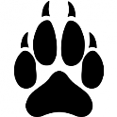
critter capers

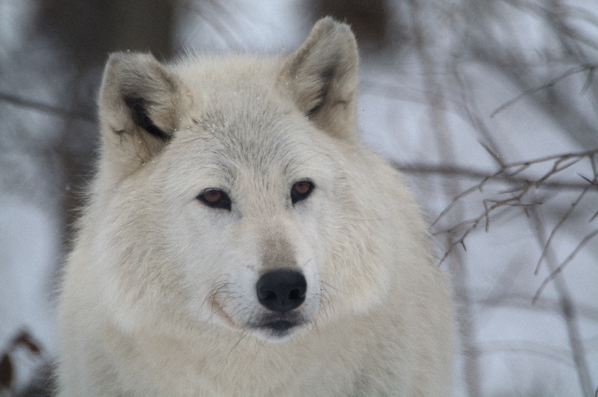
Tala

5/18/08 – 10/27/21

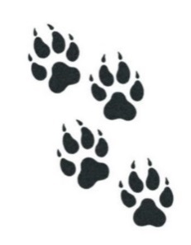

This quarter’s newsletter is dedicated to the life and memory of Tala, an Arctic/Alaskan wolf born here at the Center. Tala was one of three pups born in a cozy den with parents Nakoa and Natani keenly watching over their only offspring. Tala, with her siblings, Tashina and Dancing Turtle, spent many hours playing together until such time when Tala exerted her dominant personality and began to demonstrate increasingly adversarial behaviors toward her family. She grumped with her dad and brother and clearly did not like her mother. For the safety of all, Tala was given her own space in which to live. Her new living arrangements were small and unfortunately it took many years to find the right personality match for Tala for a companion. With Caretakers, Tala was an absolute sweetheart and would come running when she heard her name, typically whimpering in excitement as she greeted her favorite humans. Finally, in 2015, Tamarack came along! His sweet, easy-going, sometimes goofy temperament was a perfect match for Tala. Introduced at about four months old, Tamarack’s charm won over the finicky Tala who absolutely adored Tamarack. For the next six years the two would thrive with each other’s companionship and could usually be found in close proximity to one another. As the older, wiser wolf, Tala showed Tamarack how to participate in enrichment activities such as ripping into wrapped boxes or swinging pinatas to reach the tasty treats hidden within. The two quickly became visitor favorites and would put on a show during howl programs or scent rolling demonstrations. They shared their cabin when winter weather became too wild for even a wolf. They played, chased and ran together. Not surprisingly, Tamarack seemed to be aware of his packmate’s health issues even before staff. Toning down his usually rambunctious self, Tamarack gently pawed Tala and whimpered when she was in pain and as her health declined. One morning Caretakers noticed Tala suddenly had a swollen front leg. Though not common, the animals do sometimes trip in cache holes, land off balance when jumping or running, or even step wrong when walking on uneven ground. After a consultation with the veterinarian, Tala was treated with anti-inflammatories and pain medicines to see if her condition would improve. Two weeks later no improvement was seen so a trip was made to the veterinarian’s clinic for x-rays. Expecting that perhaps Tala had a very severe sprain or maybe even a broken leg, we were devastated and heartbroken to discover she had bone cancer which had essentially eaten away at her leg as well as metastasized to her chest cavity. After weighing the limited options and what was best for Tala’s discomfort, the gut-wrenching decision was made to release Tala from her excruciating pain and not prolong the inevitable. Two weeks later and the tears still flow as staff recall our wonderful memories, experiences, and special moments with Tala. Run free beautiful one.....

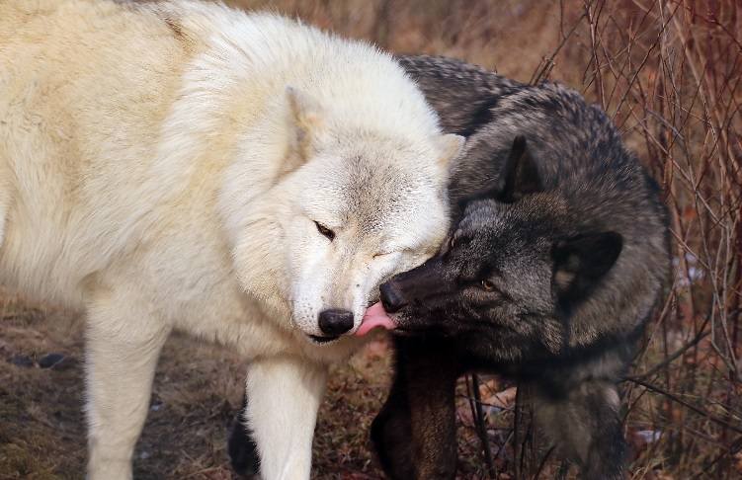
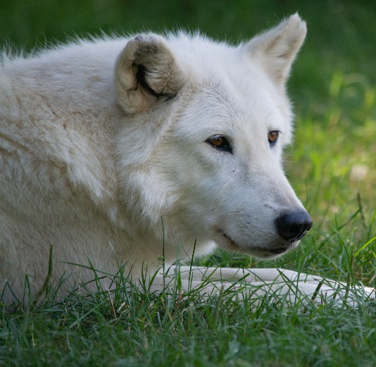
Tala memories

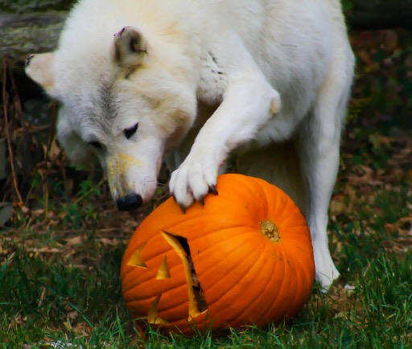
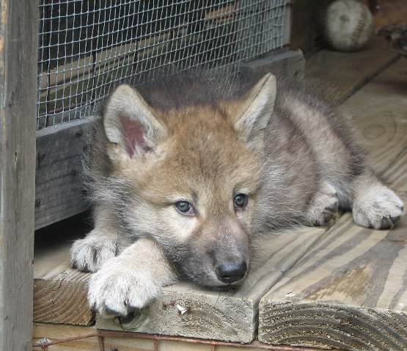

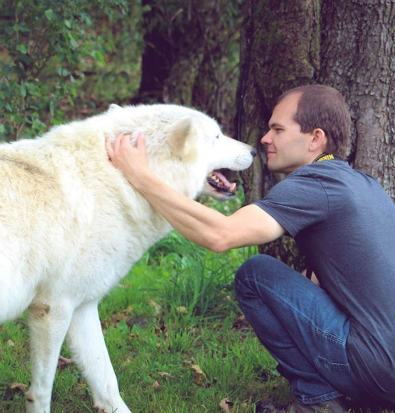

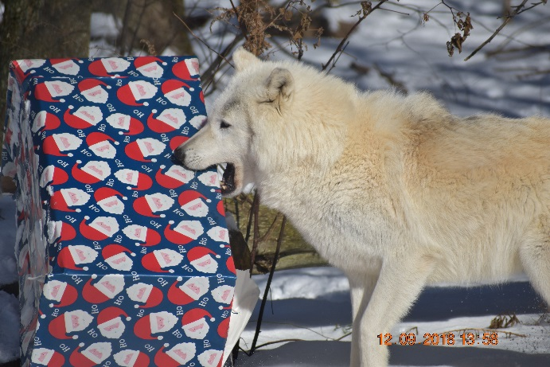

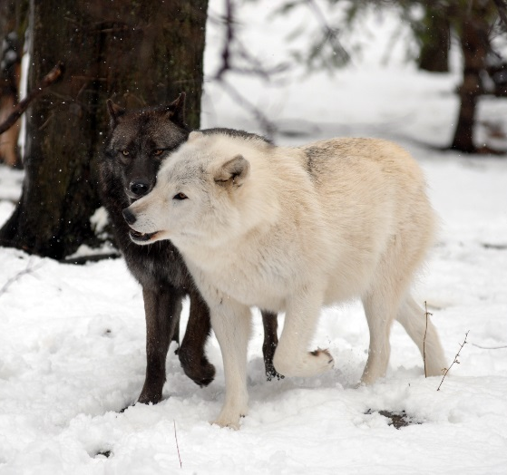

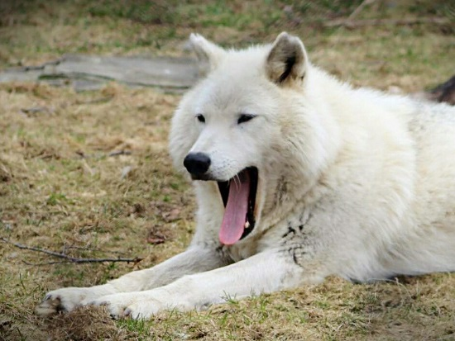
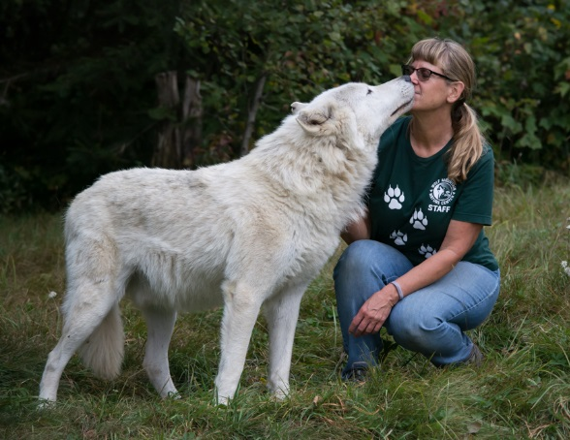

Director Dialog...Erin Lord-Astles

As winter approaches, so too do excellent conditions for winter tracking. Tracking is not only something of a lost art but is also a highly popular technique used by field biologists because it is non-invasive; tracking does not require one to physically capture an animal or negatively impact it’s natural routine in any way in order to collect data. Ultimately, to become a good tracker one needs to practice, as well as understand all the factors that contribute to why a footfall registers in a certain way.
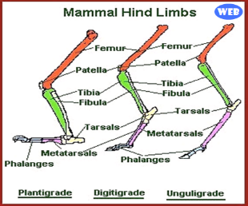
Firstly, understanding animal morphology and locomotion is key to reading tracks. Let’s look at the body plans of mammals. Plantigrade animals, such as humans, bears, or rodents all are slower moving animals that walk with their entire foot, heel to toe, flat on the ground. Note that unguligrade animals like deer and digitigrade animals like wolves and felines have the same body plan that we do, it’s just modified for efficiency of movement in something called cursorial locomotion. Wolves literally walk on the balls of their feet with their heels up in the air (think what it’s like wearing high heel shoes), while deer run on their tippy toes (like us wearing ballerina shoes). The elongated limbs and reduced number of digits in a wolf is designed for forward momentum as they chase down large ungulate prey species at high speeds.
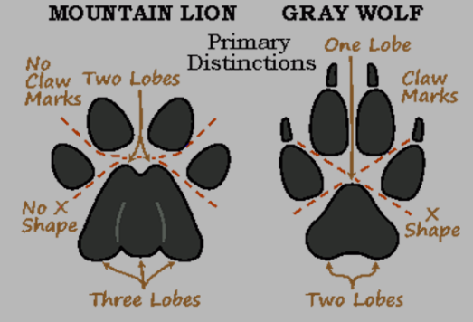
The track pattern of a canid (dog, wolf, fox) shows a triangular shaped palm pad, called a metacarpal pad. No heel pad (called a proximal pad) shows because they run on the balls of their feet. A typical track shows four toes on each foot. Wolves do have a 5th digit on their front feet, but the dewclaw sits high enough on the leg not to register in track patterns. If we compare canid tracks to felid, we can see that wolves show heavy claws where the retractable claws of a mountain lion are often absent. If one was to draw an “X” between the outer toes of a canid, that “X” fits perfectly without falling within boundaries of the palm pad, this does not work for any other class of animal.
Even in deep snow, when the unique identifying features of a track are indistinguishable, one can learn to ID tracks based on their gait, or pattern of movement. Tracks patterns will look quite different in an animal that is slowly walking towards a den, trotting towards a playmate, or running after a meal in deep snow. The easiest tip for a layman is to recognize the direct, purposeful movements of a wild canid versus the seemingly random wanderings of a domestic dog that just has to pee on every tree at the park.
My best tip for beginners is to acquire good reference material, I personally like The Tracker’s Field Guide, 2nd edition by James C. Lowery. I like to think of a set of tracks as CSI Wildlife; I have a scene before me and need to find clues to identify my suspect. I first look at habitat (who might live here?). I then look at the shape of the palm pad and if the heel pad is present or absent (for example: 4 toes and no heel pad mean digitigrade animal, “X”-shape means canid). I might measure the size of the track, the stride between steps, or the straddle between right and left feet to get a clue as to the size of the animal. I would then look at my field guide and make three guesses as to possible animals-of-interest and then look at key identifying features, such as how precisely the toes are splayed, to eliminate my suspects and identify the culprit. Tracking isn’t just about footfalls, animals leave all sorts of marks on a landscape, you can also look for signs on vegetation or the ground, kill sites or midden, scat, etc. All one has to do is follow a track pattern, observe, and use critical thinking to read tracks. Get out there this winter and give it a try!

Studying the Impacts of Different Colors of Fladry on Wolf Avoidance Behavior
by Alex Gross, Summer 2021 Intern/Volunteer

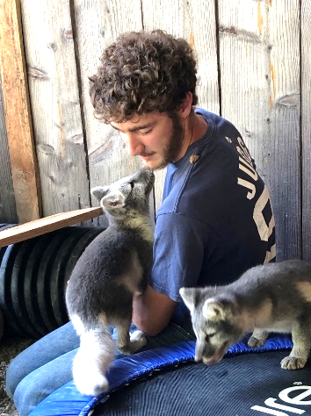
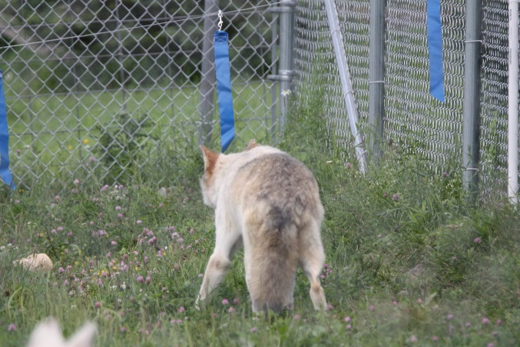
As our human population continues to grow, development will place more pressure on ecosystems that preserve our planet’s remaining diversity. One of the many negative impacts that come with human development, directly outside of ecosystems, is an increased occurrence of human-wildlife conflict). Free-ranging large social carnivores are among the species propelled into conflict with humans, and the extent to which humans support coexistence with these carnivores depends on how they are valued and how well we can mitigate the conflict. Human-wildlife conflict encompasses a wide variety of species from the smallest of rodents to large charismatic carnivores such as wolves. Coexistence with such species is often difficult, as livestock depredation impose significant costs onto the people that must coexist with these species. The response to such conflict is often lethal control, which poses a major threat to the species involved.
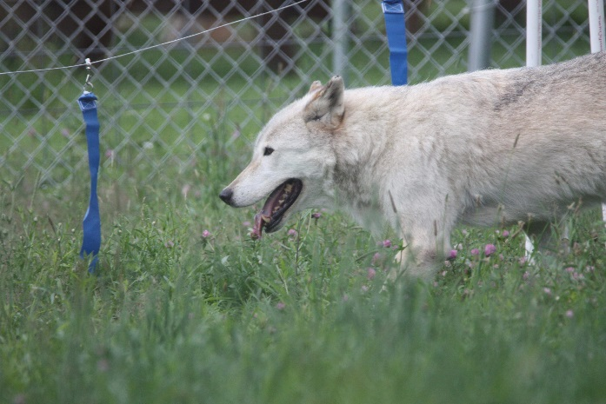
Wolves and humans have a long history of conflict in the United States. This began when humans made the transition from hunters to farmers. Human settlers bringing their livestock across the country made for easy prey for wolves and thus, conflict with humans began. Wolf bounties reached their apex in the United States, as it was estimated that between 1883 and 1918 alone, around 80,000 wolves were killed via bounty hunters, however this number is in question. By around 1900, the wolf had been nearly eliminated from all its eastern U.S. range. The incentivization of wolf killings lasted until the mid-1960s, until public support for the wolf increased, and it gained protections under the U.S Endangered Species Act in 1974. As a result of the keystone role wolves play in their ecosystems, in addition to their economic significance, the need for research centered around mitigating conflict with humans is crucial.
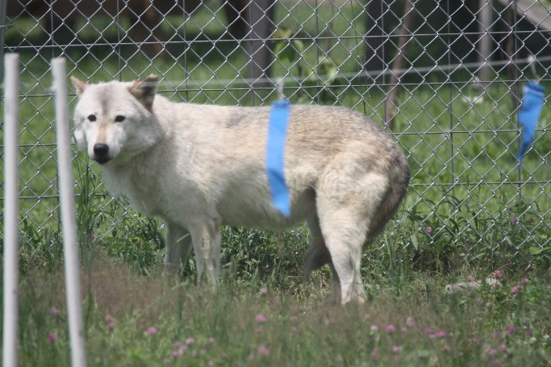
This past summer, while I was interning at Wolf Mountain, I undertook research exploring the impacts of different colors of fladry on wolf avoidance behavior. Fladry is often used as a method to mitigate human-wildlife conflict, and was developed specifically for wolf deterence. Much of the fladry that is seen will use orange flags, which is what sparked my idea for this research. Dogs (and this includes wolves) have dichromatic vision, and their visible spectrum is divided into two hues. These hues fall between 430 – 475 nanometers on one end of the spectrum, which is seen as blue, and 500 – 620 nanometers on the other end of the spectrum, which is seen as yellow. Dogs have trouble differentiating colors between the blue and yellow ends of the spectrum. Orange falls in the area of the spectrum where wolves would have trouble picking up on the color. As such, my Dad and I developed our own fladry using blue and yellow flags (with a clear flag control group) to determine if wolves exhibited more avoidance behavior in the experimental treatments (blue and yellow flags), compared to the control treatment (clear flags). Dancing Turtle and Tashina were my “test individuals” and Tashina stole the show, exhibiting many of the behaviors I was looking for. I am currently working through the data and running statistics, and will eventually put it all together into a research poster.
Honoring the Spirit of the Wolf
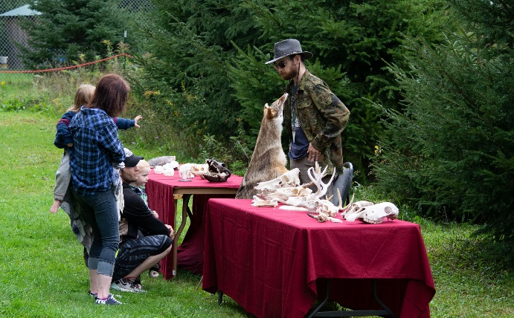
October 10, 2021

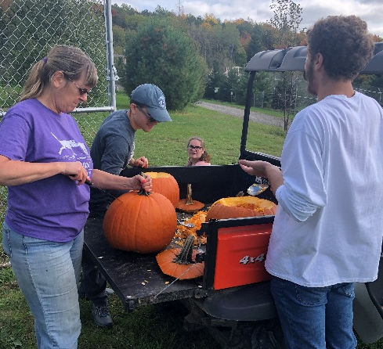

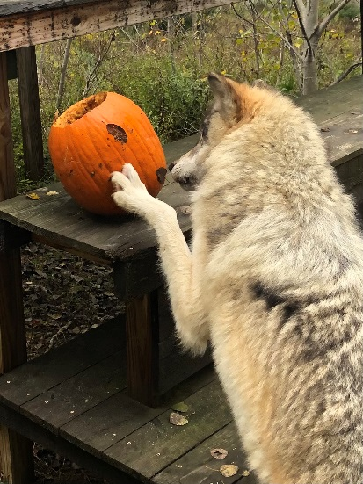
This year marked our 15th anniversary! Every year since our opening to the public in 2006, we have held our annual fall celebration to honor the incredible wolf and its magnificent spirit. Visitors assisted with the filling of pumpkins for the animals, met sled dogs, watched enrichment presentations, and enjoyed treats from various food vendors.

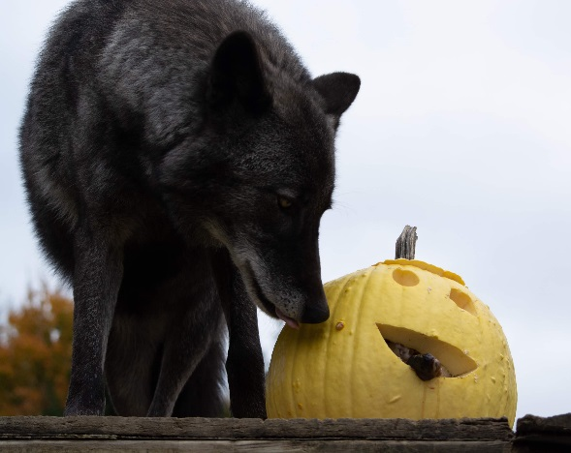

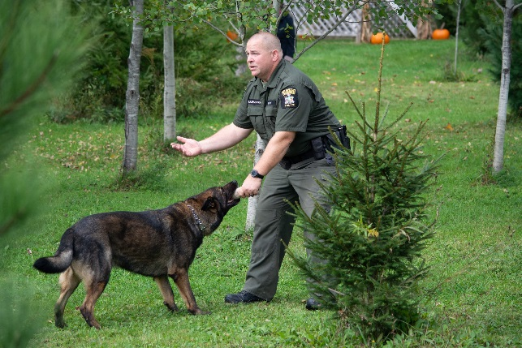
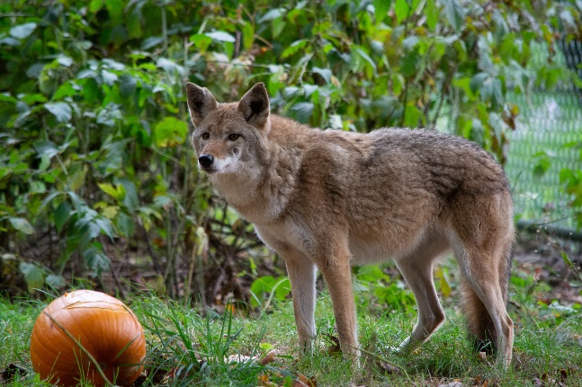

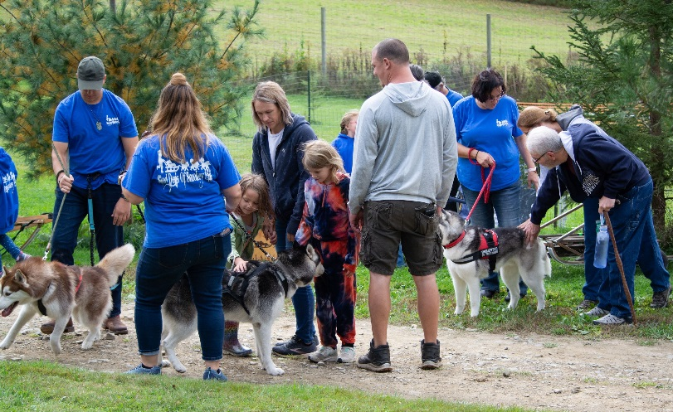

Winter with the Wolves
Sunday, December 12, 2021
11 am – 3 pm

- Watch the animals open their holiday gifts!
- Sled Dogs of Smokey Hill
- Nature trails open for hiking or snowshoeing (bring your own)
- Santa & The Grinch
- hot cocoa & snacks
- gift shop

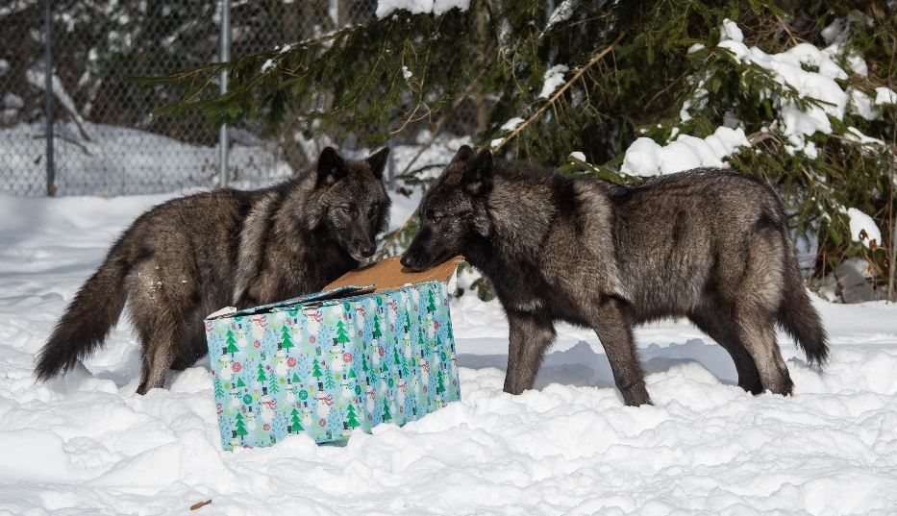

admission only $8/person; kids 5 & under free
only cash accepted in admissions & gift shop

~~~~~~~~~~~~~~~~~~~~~~~~~~~~~~~~~~~~~~~~~~~~~~~~~~~~~~~~~~~~~~~~~~~~~~~~~~~~~~~~~~~~~~~~~~~~~~~~~~
Wishes and Wants: As a non-profit we rely heavily on donations. Below are some of the many items that would help the center. If you can help, please contact us or simply bring the item(s) on your next visit!

Office/Classroom
Postage stamps
AA batteries
Brown paper lunch bags
30 or 55-gallon garbage bags
Toilet Paper
Baby wipes
Non-latex gloves (large/XL)

Landscaping/Maintenance
Picnic tables & benches
Solar lights (for pathways)
Wheelbarrow (heavy duty)
Solar-operated fountain
Exterior screws (2.5-3” size)
Lag construction screws (3-4” size)
Working push mower
Animal Care
Metal rakes/shovels
Metal “pooper-scoopers”
Walleye scoop net
Old fire hoses
6’ round/oval galvanized water troughs
No-climb horse fence (4’ or 6’ height)
Commercial grade garden hose (3/4”)

Do you shop on Amazon?
Please consider using our Amazon.smile link smile.amazon.com/ch/20-5274163
Copy and paste into your browser and shop on Amazon as usual.
Amazon will donate to us a percentage of your purchase costs at
no additional expense to you!

Open Hours and Admission Rates *Last admission is 30 minutes prior to closing time.
 | Sundays | Mon. | Tues. | Wed. | Thurs. | Fridays | Saturdays
Regular Season  September 1 – June 30  (closed in January) | Open 12 – 4 pm  Various animal enrichment programs;  Self or Guided Tours at 12:30 and 2:00 pm | Closed | Closed | Closed | Closed | Closed | Closed
Summer Season  July 1 – August 31 | Open 12 – 4 pm  Various animal enrichment programs;  Self or Guided Tours at 12:30 and 2:00 pm | Closed | Closed | Closed | Closed | Open 12 – 3 pm  Various animal enrichment programs;  Self-Guided Tours | Open 12 – 3 pm  Various animal enrichment programs;  Self-Guided Tours
Admission | Children 5 & under Free  Folks 6 & up $8.00 | Closed | Closed | Closed | Closed | Children 5 & under Free  Folks 6 & up $8.00 | Children 5 & under Free  Folks 6 & up $8.00
* CLOSED November 21, 2021 and from December 26 – February 5, 2022*
2021 Special Programs

Wolf Photography

February 19, 2022
10 - 12 pm

Fee: $100; pre-registration via website

Includes photo shoots at our two platforms above fence lines and a guided tour of the Center. Participants do not enter enclosures; this is an opportunity for you to bring your own camera and photograph the animals.

Arctic Fox
Photography Sessions

Sundays during the months of February & March at 12:30 pm

$50 fee; preregistration via website; walk-ins accepted if space permits. Must be 16 or older to participate.

Includes a 30-minute presentation in our heated classroom followed by a trip to our fox enclosures to take pictures for up to 45 minutes.

Please Note:

Due to Covid-19 and ever-changing mandates & regulations, any or all of our planned events/activities may be abruptly cancelled or postponed. We apologize in advance if this happens, but it is out of our control. Certainly, we will abide by rules passed down and want everyone to stay as safe as possible. If you have pre-paid for an activity that is cancelled due to federal or local mandates, we will offer you one of the following options: refund, credit toward a future event, credit toward merchandise at our gift shop, or accept your money as a donation to be used for animal care expenses.

We appreciate your understanding.

